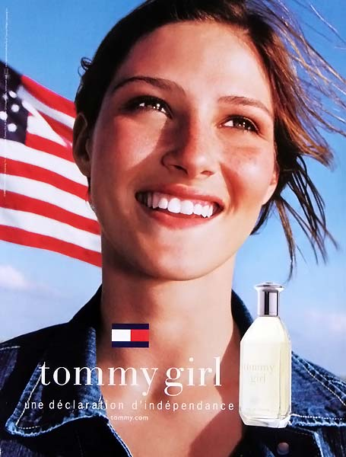

Marketing the Girl Next Door: A Declaration of Independence?
[1] Found in Seventeen magazine, the advertisement for “tommy girl," the perfume manufactured by Tommy Hilﬁger, sells the most basic American ideal of independence. Various visual images and text suggest that purchasing tommy girl buys freedom and liberation for the mind and body. This image appeals to young women striving to establish themselves as unbound individuals. Ironically, the advertisement uses traditional American icons as vehicles for marketing to the modern woman. Overall, the message is simple: American individualism can be found in a spray or nonspray bottle.

[2] Easily, the young woman dominates the advertisement. She has the look of the all-American “girl next door." Her appealis a natural one, as she does not rely on makeup or a runway model's cheekbones for her beauty. Freckles frame her eyes that ambitiously gaze skyward; there are no limits restricting women in capitalist America. Her flowing brown hair freely rides a stirring breeze. Unconcerned with the order of a particular hairstyle, she smiles and enjoys the looseness of her spirit. The ad tells us how wearing this perfume allows women to achieve the look of self-assured and liberated indifference without appearing vain.

[3] The second most prevalent image in the advertisement is the American flag, which neatly matches the size of the young woman's head. The placement and size of the flag suggest that if anything is on her cloudless mind, it is fundamental American beliefs that allow for such self-determination. The half-concealed flag is seemingly continued in the young woman's hair. According to the ad, American ideals reside well within the girl as well as the perfume.

[4] It is also noticeable that there is a relative absence of land surrounding the young woman. We can see glimpses of ”fruited plains" flanking the girl's shoulders. This young woman is barely bound to earth, as free as the clouds that float beneath her head. It is this liberated image Americans proudly carry that is being sold in the product.

[5] The final image promoting patriotism can be found in the young woman's clothing. The young woman is draped in the blue jean jacket, a classic symbol of American ruggedness and originality. As far as we can see, the jacket is spread open, supporting the earlier claim of the young women's free and independent spirit. These are the very same
ideals that embody American pride and patriotism. The ad clearly employs the association principle in linking the tommy girl fragrance with emotionally compelling yet essentially unrelated images of American nationalism and patriotism.

[6] A final obvious appeal to American nationalism is the tagline of the advertisement, the underlying message being “a declaration of independence.” The young woman has already declared her independence, and now it is your turn. Doesn’t every young woman want to be in that green field, hair blowing in the wind, wearing a confident look outlined against an American flag and clean, carefree, endless blue sky?

[7] Lastly, the advertisement utilizes several implicit arrows that point to the actual product of tommy girl perfume. The white writing against the dark blue jean jacket catches the eye first, encouraging the reader to continue in the traditional, left ot right order. When the writing stops, we are naturally pointed toward the product. In addition, the young woman’s hair, seen earlier as an extension of the American flag, is flurrying out and somewhat downward. We follow the hair to its end, where it seemingly kisses the product’s cap. All visual indications of direction in the advertisement lead the viewer to an inevitable end: the irresistible scent of tommy girl perfume.

[8] But we might also look beyond the ad’s overt messages, and examine its effects on the viewer and our society as a whole. Returning to the ad’s portrayal of the young woman, we are shown a girl with a natural beauty, free of worries or cares about conforming to the pressures of society as a female. Jean Kilbourne (2003) argues that countless ads tell women to search for freedom and independence through being thin, as echoed in the ad’s skinny and attractive young woman. Kilbourne actually refers to another tommy girl ad that uses the same tagline: “’A declaration of independence,’ proclaims an ad for perfume that features an emaciated model, but in fact the quest for a body as thin as the model’s becomes a prison for many women and girls” (263). She argues that ads encouraging a search for feminine independence often promote the worship of the thinness idea, as well as the dilemma of being a successful and powerful woman while remaining “feminine” and unthreatening (262-264).

[9] Additionally, the ad for tommy girl perfume is also effective because it “Takes on the trappings of a movement for social justice,” according to Thomas Frank (187). Frank describes how advertisers constantly link products with the rebellious, revolutionary political and social movements of the past in order to conjure the vehement emotions associated with their resounding emotional content. The tommy girl ad emphasizes typical patriotic American images—like the American flag and denim clothing—as well as the phrase a declaration of independence, which explicitly creates a connection between the perfume and the American colonists’ revolutionary pursuit of liberty in their beliefs and behavior during the American Revolution.

[10] Yet in reality, this marketing of liberation is paradoxical; although this freeing message promotes rebellion and nonconformity, it actually supports the market economy and feeds into capitalism and conformity. When advertisers employ political protest messages to be associated with products, they imply that buying the product is a form of political action. […] And so the viewers are simply left to decide: Does this tommy girl ad truly portray a declaration of independence, or of dependence?

Abridged Essay taken from Writing Analytically, Rossenwasser and Stephen, 4th ed., 2006, Thomson/Wadsoworth.

